RECYCLING IN CHESELBOURNE

Cheselbourne Climate Action Group has set up a recycling initiative in Cheselbourne Village Hall carpark, where you can bring items that can’t be recycled as part of the kerbside recycling service. We are now collecting CLEAN soft plastics, included in the list below, CLEAN tin foil and CLEAN tetrapaks here. The bins are emptied and the contents taken into town by volunteers, so please use this facility thoughtfully.

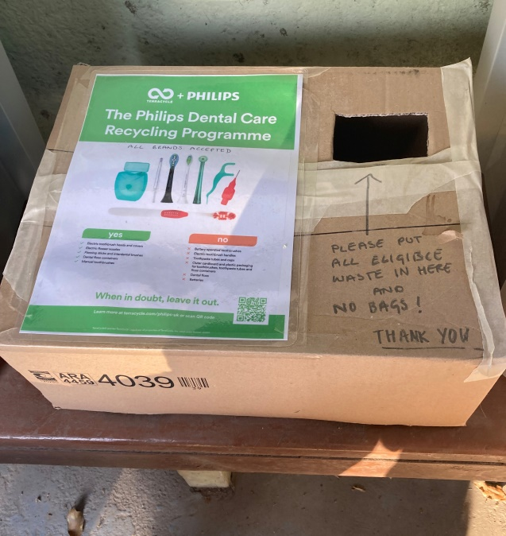
Cheselbourne School has also set up a Terracycle recycling initiative in the Bus Shelter, where you can bring dental waste, to include electric toothbrush heads, electric flosser nozzles, flossing sticks and interdental brushes, dental floss containers and manual toothbrushes. Please see the Terracycle website for more
information: https://www.terracycle.co.uk/.

Cheselbourne School is paid by weight of material recycled and so raising funds for the school.

PLASTIC RECYCLING SYMBOLS 
Plastic resin code numbers 1, 2 & 5 are ok in your kerbside recycling bin.
Plus paper, cardboard (remove packing tape) and food tins

The following are not –

Cling film | Hand soap pump dispenser tops
Non-paper gift wrap | Coffee cups
Kitchen roll | Tissues
Glass cookware | Window glass
Straws | Greasy takeaway food boxes
Soft plastic/laminated foil packaging | Photo paper
Wine glasses | Nail varnish bottles
Crisp packets | Post-it notes
Shampoo bottles and food containers that have not been rinsed | Tissue boxes where the plastic insert has not been removed

RECYCLING PLASTIC BAGS
ACCEPTED AT THE VILLAGE HALL RECYCLING BINS
OR Most large retailers accept:

All plastic bags except biodegradable or compostable
Bread bags
Breakfast cereal liners
Bubble wrap
Delivery bags
Dry cleaning bags
Prepacked veg and some fruit bags (check that the label says ‘Recycle with bags at larger stores’)
Frozen food bags (check that the label says ‘Recycle with bags at larger stores’)
Magazine and newspaper wrappers
Multi-pack wrapping
Plastic marked as low-density polyethylene (LDPE) - resin ID code 4
Toilet roll and kitchen towel wrapping

TETRAPAK & SIMILAR CARTONS
Can now be recycled at Cheselbourne Village Hall or you can take your cartons to various collection points including Fairfield Car Park, Market Street, Dorchester and Dorchester Household Recycling Centre Louds Mill.

